**Reviewer Rubric – Pediatric Audiology**

The green text is instructions for reviewers. It has been overlaid on the submission template.

Gentle reminder – please keep criticism constructive.

Reviewers will generally receive the direct comments made, which, because of the way the “Teams” system works, includes your name with the comments.

# **Descriptive Title of Case. Replace this heading with your title.**

Suggest an alternative title if the title is not sufficiently descriptive.

# **Authors**

Check that appropriate format has been used.

Jane Doe, Ph.D., University of Where Ever

John Smith, B.S., Doctoral Student of Audiology, University of Where Ever

ACKNOWLEDGMENTS: Mary Jane, Au.D., Cool Medical Externship Site, City, State

# **User Agreement**

The user agreement is within the Submission Guidelines www.AudCases.com) Type the initials of the authors below to electronically sign the user agreement, most importantly, that you have thoroughly checked that the case is completely de-identified:

Return without reviewing if the initials of ALL authors were not included.

# **Table of Content Items**

List the items for your table of content here. Do not indent. Use a separate line per item.

Content items should be listed in the order they appear in the case to facilitate your review. Add or recommend deleting items as you think appropriate.

# **Educational Level**

Choose one educational level that most adequately describes your case and delete the others.

Introductory

Intermediate

Advanced

Recommend a different educational level if needed.

# **Learning / Assessment Objectives**

Replace the list below with your own objectives. Use the format provided.

By completing this case, the student will be able to:

1. Identify the type of loss
2. Describe the loss severity

Evaluate the objectives and consider if they match the educational level. Introductory cases should use terms from the left-hand side of the list; advanced cases from the right-hand side. Considerable latitude can be permitted.

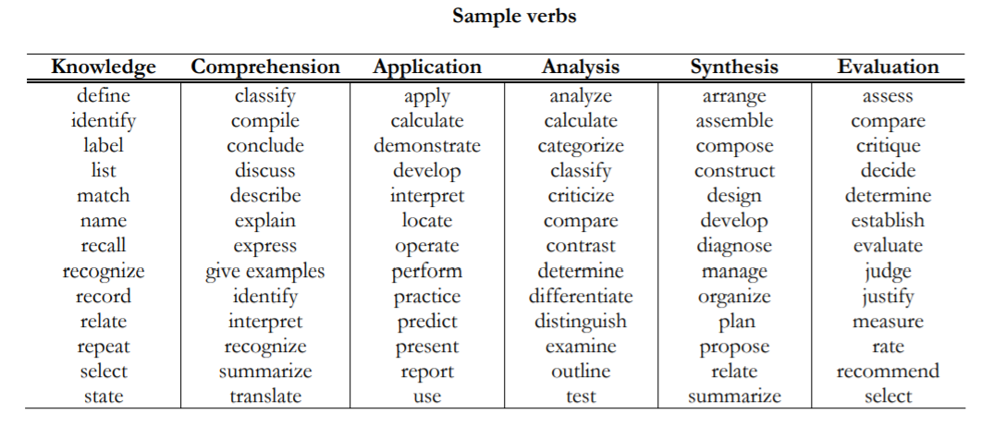

If any of the “avoid terms” are used, suggest an alternative verb.

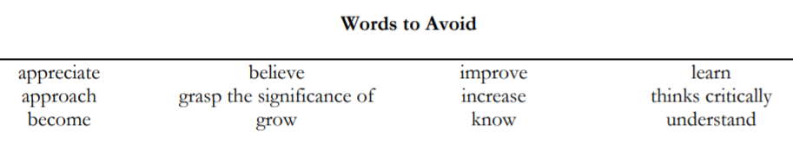

Below is guidance from the “New” Bloom’s Taxonomy.

**New Bloom’s Taxonomy**

**I. Remembering**

Exhibit memory of previously learned material by recalling facts, terms, basic concepts, and answers.

Choose • Define • Find • How • Label • List • Match • Name • Omit • Recall • Relate • Select • Show • Spell • Tell • What • When • Where • Which • Who • Why •

**II. Understanding**

Demonstrate understanding of facts and ideas by organizing, comparing, translating, interpreting, giving descriptions, and stating main ideas.

Classify • Compare • Contrast • Demonstrate • Explain • Extend • Illustrate • Infer • Interpret • Outline • Relate • Rephrase • Show • Summarize • Translate •

**III. Applying**

Solve problems to new situations by applying acquired knowledge, facts, techniques and rules in a different way.

Apply • Build • Choose • Construct • Develop • Experiment with • Identify • Interview • Make use of • Model • Organize • Plan • Select • Solve • Utilize •

**IV. Analyzing**

Examine and break information into parts by identifying motives or causes. Make inferences and find evidence to support generalizations.

Analyze • Assume • Categorize • Classify • Compare • Conclusion • Contrast • Discover • Dissect • Distinguish • Divide • Examine • Function • Inference • Inspect • List • Motive • Relationships • Simplify • Survey • Take part in • Test for • Theme •

**V. Evaluating**

Present and defend opinions by making judgments about information, validity of ideas, or quality of work based on a set of criteria.

Agree • Appraise • Assess • Award • Choose • Compare • Conclude • Criteria • Criticize • Decide • Deduct • Defend • Determine • Disprove • Estimate • Evaluate • Explain • Importance • Influence • Interpret • Judge • Justify • Mark • Measure • Opinion • Perceive • Prioritize • Prove • Rate • Recommend • Rule on • Select • Support • Value •

**VI. Creating**

Compile information together in a different way by combining elements in a new pattern or proposing alternative solutions.

Adapt • Build • Change • Choose • Combine • Compile • Compose • Construct • Create • Delete • Design • Develop • Discuss • Elaborate • Estimate • Formulate • Happen • Imagine • Improve • Invent • Make up • Maximize • Minimize • Modify • Original • Originate • Plan • Predict • Propose • Solution • Solve • Suppose • Test • Theory • Maximize • Minimize

Anderson, L. W., & Krathwohl, D. R. (2001). A taxonomy for learning, teaching, and assessing, Abridged Edition. Boston, MA: Allyn and Bacon.

<https://www.apu.edu/live_data/files/333/blooms_taxonomy_action_verbs.pdf>

Please check each question throughout the sections.

If a question is not clearly written or contains grammar or spelling errors, please provide suggested improvements.

For multiple choice questions, if the student could deduce the correct answer because it is the longest one, either suggest a revision or point out the problem and return it to the author(s) to correct. Confirm that there is only one correct answer – and that it is completely correct.

* Questions should be bulleted in this style.
* Answers should appear immediately after the question asked

The standard headers are below. Encourage use of them if appropriate. Permit other headings if educationally relevant. The sections listed in the template are noted below.

Check the quality of images. They must be clear and neat. Do not accept images with poor scan quality, titled images or poor graphics (exceptions may occasionally need to be made.)

Be vigilant in looking for identifying patient information. Initials and common first names may be used. Last names, patient ID numbers and exact dates of birth should not appear.

The names of individual practitioners should not be used unless they are authors or donors of the case.

Review all sections for appropriateness, clarity. The standard tables must be used unless the submitter has justified the use of an alternative format. Send submissions with poor quality graphics back to the submitter

# **Case History**

Initials, a __ year old (gender if appropriate), . . .

* What question do you want to insert here? Delete if no question is to be used.
* If a question is given, please provide the answer to the question as it would appear in the Instructor Guide. Delete this bullet if no question is to be used.

# **Otoscopy**

* What question do you want to insert here? Delete if no question is to be used.
* If a question is given, please provide the answer to the question as it would appear in the Instructor Guide. Delete this bullet if no question is to be used.

# **Tympanometry**

226 Hz / Y tympanograms should be included in this section. For infants, if a 1000 Hz tympanogram is used, please make note in text and omit the Multifrequency section below if only the 1000 Hz Y trace was obtained.

* What question do you want to insert here? Delete if no question is to be used.
* If a question is given, please provide the answer to the question as it would appear in the Instructor Guide. Delete this bullet if no question is to be used.

# **Advanced Middle Ear Analysis**

If multiple types of middle ear analysis are included, please use this ordering. Omit sections for tests not performed.

## **Multifrequency Tympanometry**

Provide traces. The preferred format is for B/G traces to be on the same printout with a separate Y trace.

Ensure that probe frequency is clearly noted.

* What question do you want to insert here? Delete if no question is to be used.
* If a question is given, please provide the answer to the question as it would appear in the Instructor Guide. Delete this bullet if no question is to be used.

## **Wideband Acoustic Immittance (WAI)**

Provide high-quality graphics

* What question do you want to insert here? Delete if no question is to be used.
* If a question is given, please provide the answer to the question as it would appear in the Instructor Guide. Delete this bullet if no question is to be used.

## **Middle Ear Absorption**

Provide high-quality graphics

* What question do you want to insert here? Delete if no question is to be used. Questions can be moved to the subheadings above, they need not appear after all of the middle ear data are provided.
* If a question is given, please provide the answer to the question as it would appear in the Instructor Guide. Delete this bullet if no question is to be used.

# **Acoustic Reflexes**

## **Thresholds**

Please put acoustic reflex results in the table below. Thresholds are assumed to be in dB HL. If in dB SPL then change the upper left-hand table notation AND note in text.

|  |  |  |  |  |  |  |
| --- | --- | --- | --- | --- | --- | --- |
| **(dB HL)**  **Probe Ear** | **Hz 🡪**  **Stimulated Ear (Mode)** | **500** | **1000** | **2000** | **4000** | **BBN** |
| Right | Right  (Ipsi) | 85 | 105 | 110 | Absent | 95 |
| Right | Left  (Contra) | 80 | 100 | Absent | Absent | 90 |
| Left | Left  (Ipsi) | 90 | 105 | 110 | Absent | 100 |
| Left | Right  (Contra) | 95 | 110 | Absent | Absent | 95 |

* What question do you want to insert here? Delete if no question is to be used.
* If a question is given, please provide the answer to the question as it would appear in the Instructor Guide. Delete this bullet if no question is to be used.

## **Acoustic Reflex Decay**

Insert high-quality reproductions of the test results.

* What question do you want to insert here? Delete if no question is to be used.
* If a question is given, please provide the answer to the question as it would appear in the Instructor Guide. Delete this bullet if no question is to be used.

# **Otoacoustic Emissions**

## **Transient-Evoked**

Insert high-quality reproductions of the test results.

Use of a tabular format, either as a way of presenting the results. Adjust table, adding and removing and relabeling frequencies as appropriate to the case.

|  |  |  |  |  |  |  |  |
| --- | --- | --- | --- | --- | --- | --- | --- |
|  | **Freq (Hz)** | **500** | **1000** | **2000** | **3000** | **4000** | **6000** |
| **Right Ear** | **OE Level** |  |  |  |  |  |  |
|  | **SNR** |  |  |  |  |  |  |
| **Left Ear** | **OE Level** |  |  |  |  |  |  |
|  | **SNR** |  |  |  |  |  |  |

* What question do you want to insert here? Delete if no question is to be used.
* If a question is given, please provide the answer to the question as it would appear in the Instructor Guide. Delete this bullet if no question is to be used.

## **Distortion-Product**

Insert high-quality reproductions of the test results.

Use of a tabular format, either as a way of presenting the results. Adjust table, adding and removing and relabeling frequencies as appropriate to the case.

|  |  |  |  |  |  |  |  |
| --- | --- | --- | --- | --- | --- | --- | --- |
|  | **Freq (Hz)** | **500** | **1000** | **2000** | **3000** | **4000** | **6000** |
| **Right Ear** | **OE Level** |  |  |  |  |  |  |
|  | **SNR** |  |  |  |  |  |  |
| **Left Ear** | **OE Level** |  |  |  |  |  |  |
|  | **SNR** |  |  |  |  |  |  |

* What question do you want to insert here? Delete if no question is to be used.
* If a question is given, please provide the answer to the question as it would appear in the Instructor Guide. Delete this bullet if no question is to be used.

# **Audiometric Data**

Create a digital audiogram using this link. <http://www.audsim.com/audgenJS/> If alternative symbols (e.g. S or A) are needed, use the “Annotate” features. The submission guidelines document details when other formats can/should be used.

If the standard format audiogram is not used, is there an educationally relevant reason for the substitution?

Describe techniques used to obtain results (BOA, VRA, play). Describe reliability if appropriate.

* What question do you want to insert here? Delete if no question is to be used.
* If a question is given, please provide the answer to the question as it would appear in the Instructor Guide. Delete this bullet if no question is to be used.
* Use this table for speech testing results, inserting patient-specific results. If using alternative stimuli (e.g. QuickSIN) then use your preferred format. Replace SRT with SAT if appropriate.

|  |  |  |  |  |
| --- | --- | --- | --- | --- |
|  | **PTA (dB HL)** | **SRT (dB HL)** | **WRS** | **WRS Intensity (dB HL)** |
| **Right Ear** | 80 | 80 | 44 | 100 |
| **Left Ear** | 10 | 15 | 100 | 50 |
|  |  |  |  | |
| Spondee Technique | MLV | WRS Technique | Recorded | |
|  |  | List and Number | WIPI Right: 1A Left: 2A | |
|  |  | Number of Items | Right: 25 Left: 25 | |

MLV = Monitored Live Voice PP = Picture Pointing

NU-6 = Northwestern University List 6 CID W-22 = Central Institute of the Deaf, Word List 22.

10 MD = 10 Most Difficult

NU-ChiPS = Northwestern University Children’s Perception of Speech

WIPI = Word Intelligibility by Picture Identification

PB-K = Phonetically Balanced – Kindergarten

## **Speech-in-Noise Assessment**

Use the table below. If a test other than BKB-SIN is used, replace that label with the name of the test(s) used. Delete unneeded rows.

|  |  |  |  |  |  |  |  |  |  |
| --- | --- | --- | --- | --- | --- | --- | --- | --- | --- |
| **Right Side** | **dB HL** | **SNR** | **%** | **dB HL** | **SNR** | **%** | **dB HL** | **SNR** | **%** |
| **BKB-SIN** |  |  |  |  |  |  |  |  |  |
|  |  |  |  |  |  |  |  |  |  |
| **Left Side** |  |  |  |  |  |  |  |  |  |
| **BKB-SIN** |  |  |  |  |  |  |  |  |  |
|  |  |  |  |  |  |  |  |  |  |

* What question do you want to insert here? Delete if no question is to be used.
* If a question is given, please provide the answer to the question as it would appear in the Instructor Guide. Delete this bullet if no question is to be used.

# **Click ABR**

Display results of an otoneurologic ABR here if appropriate. Delete section if not salient to the case.

Use this form if appropriate to the case. Remove normative data for use with young children. (Substitution of age-appropriate norms is encouraged.)

Click Intensity: 80 dB nHL, 21.7 clicks/second stimulus repetition rate

**I.** **Wave Peak Latencies Interpeak Latencies**

|  |  |  |  |  |  |  |
| --- | --- | --- | --- | --- | --- | --- |
|  | **I** | **III** | **V** | **I-III** | **III-V** | **I-V** |
| **Right Ear** |  |  |  |  |  |  |
| Left Ear |  |  |  |  |  |  |
| Mean * | 1.54 | 3.70 | 5.60 | 2.20 | 1.84 | 4.04 |
| Range of Normal (ms) (+/- 2 SD)* | 1.34-  1.74 | 3.40-  4.00 | 5.22-  5.98 | 1.88-  2.52 | 1.50-  2.18 | 3.68-  4.40 |
| Outer Limits for Cochlear** |  |  |  | 2.55 | 2.35 | 4.60 |

1. **Interaural Latency Differences**

|  |  |  |  |  |  |  |
| --- | --- | --- | --- | --- | --- | --- |
|  | **I** | **III** | **V** | **I-III** | **III-V** | **I-V** |
| **Difference** |  |  |  |  |  |  |
| Range of Normal (ms) (+/- 2 SD)* | .21 | .26 | .29 | .25 | .25 | .28 |
| Outer Limits for Cochlear** | .65 | .59 | .52 | .41 | .37 | .46 |

**III. Latency Increase with Stimulus Repetition Rate Increase**

|  |  |  |  |
| --- | --- | --- | --- |
|  | Wave V Latency  (at 71.1 cl/sec) | Latency Increase  (with rate increase) | Significance |
| Right Ear |  |  |  |
| Left Ear |  |  |  |

**IV.**  **Amplitude Ratio of Waves I/V**

Right Ear: ___ Normal ___ Wave I larger than Wave V ___ Wave I more than 2x Wave V

Left Ear: ___ Normal ___ Wave I larger than Wave V ___ Wave I more than 2x Wave V

**V.**  **Morphology and Replicability**

**VI. Quality of Traces - Assessment of Control Run, Artifact Rejection**

­­

**VII. Additional Comments**

**\*** Schwartz et al., 1989

** Hall & Mueller, 1997

* What question do you want to insert here? Delete if no question is to be used.
* If a question is given, please provide the answer to the question as it would appear in the Instructor Guide. Delete this bullet if no question is to be used.

# **Tone-burst ABR Testing**

Display results and include text-based information here. Ensure that results are clear in whether thresholds are dB EHL (estimated hearing loss) or dB nHL (physical intensity).

* What question do you want to insert here? Delete if no question is to be used.
* If a question is given, please provide the answer to the question as it would appear in the Instructor Guide. Delete this bullet if no question is to be used.

# **Auditory Steady-State Response Testing**

Display results and include text-based information here.

* What question do you want to insert here? Delete if no question is to be used.
* If a question is given, please provide the answer to the question as it would appear in the Instructor Guide. Delete this bullet if no question is to be used.

Introductory-level cases do not need to include these last sections (below). If the case does not include synthesis- and/or evaluation-category objectives, then it probably is not appropriate to ask the student to summarize or recommend. It may be appropriate to use the section to allow the student to tie together the facets of the case, but if “summary” questions seem redundant with questions in each section, you may want to recommend that they be omitted.

# **Summary and Discussion**

Omit this category if not appropriate to the case. You may reorder this heading vs recommendations as fits your case.

* What question do you want to insert here? Delete if no question is to be used.
* If a question is given, please provide the answer to the question as it would appear in the Instructor Guide. Delete this bullet if no question is to be used.

# **Recommendations**

Omit this category if it is not appropriate to your case.

* What question do you want to insert here? Delete if no question is to be used.
* If a question is given, please provide the answer to the question as it would appear in the Instructor Guide. Delete this bullet if no question is to be used.

# Decision –

# Does the case have educational merit?

* Reject cases that do not represent appropriate audiological assessment, unless the case has been designed to highlight the testing weakness.
* Use your discretion if the case is like other case(s). If similar cases are well represented within ACES, adding another may bloat the site.

# Is the case quality high enough to merit inclusion?

* The writing clarity, the graphics quality, and the nature of the questions and answers should all be good for a case to be accepted. A highly useful / highly educational case can be accepted if there is legitimate reason that revision and resubmission cannot overcome the deficit. For example, an unusual pathology case could be accepted with a poor-quality image.

# Case Category. This case has been submitted under Pediatric Audiology. Would it be a better fit to one of the other categories? The categories are listed below for your convenience.

Amplification

Auditory Electrophysiology

Audiogram Interpretation

Auditory Processing

Audiologic Rehabilitation

Counseling

Educational Audiology

Ethics

Hearing Conservation

Immittance and OAE

Implantables (CI and other)

Medical Audiology

Pediatric Audiology

Tinnitus and Sound Sensitivity

Vestibular Evaluation and Management